**Software Design Specification**

**For**

**Hospital Management System**

Prepared by

Ashwani Kumar Verma (16CS60R62)

Yogesh Badgotiya (16CS60R63)

Indian Institute of Technology, Kharagpur

March 12th, 2017

Revision History

|  |  |  |  |
| --- | --- | --- | --- |
| **Updated By** | **Date** | **Reason For Changes** | **Version** |
| Ashwani and Yogesh | Mar 12th, 2017 | Initial Draft | 1.0 |
|  |  |  |  |

**The Software Design Specification Outline**

The Software Design Specification (SDS) sections provide you with guidelines related to the structure and the contents of SDS document. This document will cover all the design specification of the Hospital Managements System.

**1. Introduction**

The project is to create a Hospital Management System. This design document presents the designs used or intended to be used in implementing the project. The designs described, follow the requirements specified in the Software Requirements Specifications document prepared for the project.

* 1. **Purpose of this document**

The purpose of this document is to present a detailed description of the designs of the Hospital Management System.

Firstly, this document is intended for the project group, to use the designs as guidelines to implement the project. Equally, this document is also for the team’s instructor, as it fulfils one of the requirements of the project.

* 1. **Scope of the development project**

The proposed software product is the Hospital Management System (HMS). The system will be used to get the information from the patients and then storing that data for future usage. The current system in use is a paper-based system. It is too slow and cannot provide updated lists of patients within a reasonable timeframe. The intentions of the system are to reduce over-time pay and increase the number of patients that can be treated accurately. Requirements statements in this document are both functional and non-functional. The document only covers the requirement specification for the hospital management system. This document does not provide any references to the other component of the hospital management system. All the external interfaces and the dependencies are also identified in this document.

* 1. **Definitions, acronyms, and abbreviations**
* HMS – Hospital Management System
* SRS – Software Requirement and Specifications
* SDS – System Design Specifications

**1.4 References**

* IEEE Standard Design Document Format
* IEEE SRS Document Format
* UML Standards
  1. **Overview of document**

We have covered following diagrams in this SDS –

* Block Diagram
* Use case diagrams
* Use Case scenario
* Package diagram
* Context diagram
* Data flow diagram

**Block Diagrams:**



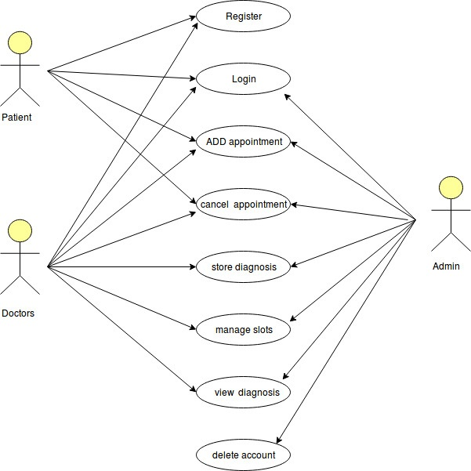**Use Case Diagrams:**

**Use case scenario:**

1. **Registor**

|  |  |
| --- | --- |
| **Purpose** | Account Creation |
| **User** | Patient or Doctor |
| **Input Data** | Data entered by the Patient or Doctor |
| **Output Data** | Updated Patient Or Staff database |
| **Pre-conditions** | Patients or doctors is connected to the Internet and on the HMS account creation page. |
| **Post-conditions** | Patients or doctors is connected to the internet and on the account creation confirmation page. |
| **Basic Flow:** | Patients or doctors create their account and their details are fed into the Patient or Staff database |

1. **Login**

|  |  |
| --- | --- |
| **Purpose** | Access Account |
| **User** | Patients or doctors |
| **Input Data** | Data entered by Patients or doctors |
| **Output Data** | Corresponding Account web Access |
| **Pre-conditions** | Patients or doctors has access to the Patients or staff database. |
| **Post-conditions** | Web Account webpage has been generated. |
| **Basic Flow:** | Administrator validate staff or Patient  And they are able to access this accounts |

1. **Add Appointment**

|  |  |
| --- | --- |
| **Purpose** | Add patient’s appointment |
| **User** | Patients or doctors |
| **Input Data** | Data entered by patients or doctors |
| **Output Data** | Updated patients database |
| **Pre-conditions** | Patient or Doctor is connected to the Internet find the website URL. |
| **Post-conditions** | patient is connected to the Internet and assign a appointment time. |
| **Basic Flow:** | patients feed their details to the appointment database. |

1. **Cancel Appointment**

|  |  |
| --- | --- |
| **Purpose** | Cancel appointment |
| **User** | Administrator/doctor/patient |
| **Input Data** | Appointment database |
| **Output Data** | Appointment database |
| **Pre-conditions** | Administrator/doctor/patient has access to the event and appointment database. |
| **Post-conditions** | Events page has been updated. |
| **Basic Flow:** | Administrator disseminates the appointment of patient. |

1. **Store Diagnosis**

|  |  |
| --- | --- |
| **Purpose** | Store diagnosis |
| **User** | doctor |
| **Input Data** | Data entered by doctor |
| **Output Data** | diagnosis Database |
| **Pre-conditions** | patient is connected to the Internet and get the appointment. |
| **Post-conditions** | patient is connected to the Internet and he is get the diagnosis. |
| **Basic Flow:** | Patient get the diagnosis about the medical problem. |

1. **Manage Slots**

|  |  |
| --- | --- |
| **Purpose** | Manage slot |
| **User** | Doctor |
| **Input Data** | Calendar & slot Database |
| **Output Data** | Feedback regarding action |
| **Pre-conditions** | Doctor is connected to the Internet and see the slot information. |
| **Post-conditions** | Doctor is connected to the Internet and get the feedback. |
| **Basic Flow:** | Doctor see the slot information and get the feedback. |

1. **View Diagnosis**

|  |  |
| --- | --- |
| **Purpose** | View diagnosis |
| **User** | Patient &doctor |
| **Input Data** | Calendar or Slot and diagnosis Database |
| **Output Data** | Corresponding page data. |
| **Pre-conditions** | Doctor & patient is connected to the Internet and see the diagnosis information. |
| **Post-conditions** | Doctor/patient is connected to the Internet and get the feedback. |
| **Basic Flow:** | Doctor provide the diagnosis and patient get the diagnosis information. |

1. **Delete Account**

|  |  |
| --- | --- |
| **Purpose** | Remove patient & Doctor account |
| **User** | Adminstrator |
| **Input Data** | Patient & Staff Database |
| **Output Data** | Corresponding FeedBack Of Action. |
| **Pre-conditions** | patient is connected to the Internet and have an account. |
| **Post-conditions** | Admin is connected to the Internet and Has to be on Delete Acoount Page |
| **Basic Flow:** | doctor has remove the patient & staff account. |

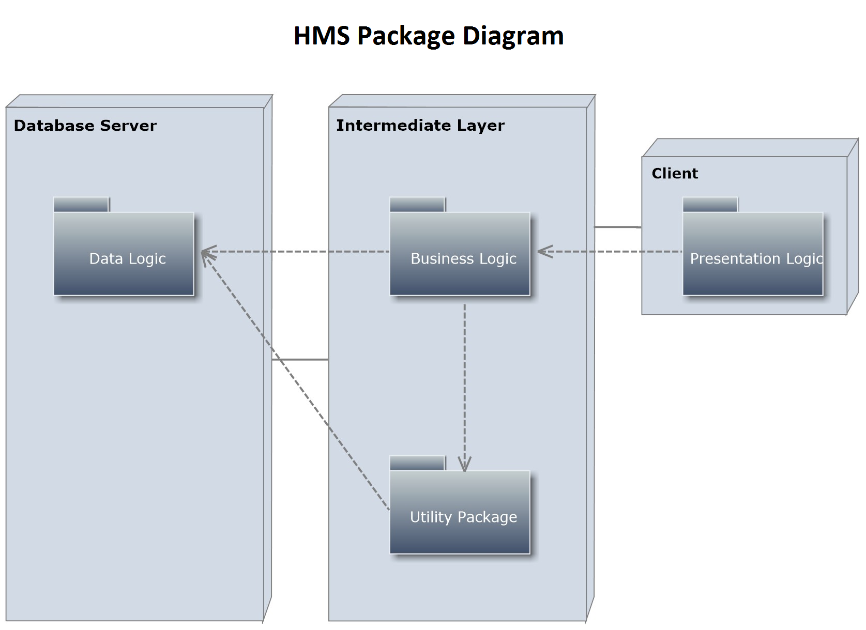**Package Diagram:**

**Context Diagram:**

Patient

Database

1. Generate Survey Form 2. Generates Event.

3. Ask For Fund.

Admin

1. Patient Database.
2. Staff Database.
3. Appointment Database.
4. Diagnosis Database.
5. OperationSchedule Database.

Hospital Management

System

Staff

1. Creates Account 2. Access Account

3. Schedule Appointment

4. Update Diagnosis

1. Creates Account 2. Access Account

3. Schedule Appointment

**Data Flow Diagram:**

# Level 0

# Level 1

